People's Democratic Republic of Algeria
Ministry of Higher Education and Scientific Research
Djilali Bounaama Khemis Miliana University

Faculty of Sciences and Technology
Department of Technology

A Dissertation Submitted in partial Fulfillment of the Requirements for the master’s degree in electrical engineering

Theme: Power frequency monitoring in electricity grid using Arduino
Presented by: Mr. Dlheiane Carimo Henrique
Supervisor: Dr. Kaci Meziane
President: Pr. Matallah M
Examiner: Dr. Karamostaph.C

2022 -2023

Acknowledgement
I would like to express my gratitude to God for giving me the strength to complete my project. I want to thank my parents, Henrique Gabriel (may he rest in peace) and Antonieta Sitoe, for their unwavering support throughout my academic journey. My uncles, Manuel Sitoe and Natalia Ubisse, have also been there for me from the beginning.
A special thanks goes to my supervisor, Dr. Meziane Kaci, for being available, supportive, and providing valuable advice throughout the process of completing my dissertation.
I am also grateful to my friend Habiby Djabu and Mme Ayadi, who played significant roles in my academic life here in Algeria. I pray that Allah blesses them and their families. I would also like to acknowledge my brothers, cousins, uncles, and classmates for their support.
Lastly, I cannot forget to mention the other professors who have shared their knowledge with me over the past six years, contributing to my academic development.

Dedication
This project holds a special dedication to the most important people in my life. First and foremost, I dedicate it to my beloved mother. I also dedicate this project to my late father, may his soul rest in peace. His presence may no longer be with us, but his spirit and teachings continue to inspire me.
Furthermore, I extend my heartfelt gratitude to my auntie Natalia Ubisse and uncle Manuel Sitoe. With their guidance and assistance, I have received countless opportunities for growth and success. Their wisdom and unwavering belief in my potential have propelled me forward, always reminding me of the immense potential within me

Abstract
The main focus of this project is to create a device that will be very useful in keeping track of the frequency of the power in an electrical network. It's important to understand that the frequency of the power plays a significant role in how the electricity network functions. We want to ensure that the frequency remains stable, which means it doesn't fluctuate too much. To make sure of this, we need devices that can monitor the frequency and give us information about it.
A frequency meter is a device used to measure and monitor the frequency of an electrical signal. In the context of the electricity grid, frequency meters play a crucial role in ensuring the stability and reliability of the power supply. They enable the monitoring of the AC frequency and help in maintaining it within acceptable limits. Frequency meters are essential for detecting deviations in frequency that can impact the performance of electrical equipment and the grid as a whole.
This device will help us keep an eye on the power frequency and make any necessary adjustments to maintain its stability.

Keywords:
Electricity grid, Arduino Board, Frequency grid, Proteus,

Résumé
L'objectif principal de ce projet est de créer un appareil qui sera très utile pour suivre la fréquence de l'alimentation dans un réseau électrique. Il est important de comprendre que la fréquence de l'électricité joue un rôle important dans le fonctionnement du réseau électrique. Nous voulons nous assurer que la fréquence reste stable, c'est-à-dire qu'elle ne fluctue pas trop. Pour s'en assurer, nous avons besoin d'appareils capables de surveiller la fréquence et de nous donner des informations à ce sujet.
Un fréquencemètre est un appareil utilisé pour mesurer et surveiller la fréquence d'un signal électrique. Dans le contexte du réseau électrique, les fréquencemètres jouent un rôle crucial pour assurer la stabilité et la fiabilité de l'alimentation électrique. Ils permettent de surveiller la fréquence AC et aident à la maintenir dans des limites acceptables. Les fréquencemètres sont essentiels pour détecter les écarts de fréquence qui peuvent avoir un impact sur les performances des équipements électriques et du réseau dans son ensemble.
Cet appareil nous aidera à garder un œil sur la fréquence du réseau et à effectuer les ajustements nécessaires pour maintenir sa stabilité.

Les mots clés :
Réseau électrique, la carte Arduino, fréquence du réseau, Proteus

Table of contents

Acknowledgement……………………………………………………………………………… i
Dedication…………………………………………………………………………...…………. ii
Abstract……………………………………………………………………..…………………. iii
Keywords……………………………………………………….……………..……….………. iii
Résumé…………………………………………………….…………………….……..………. iii
Les mots clés ………….………………………………………………………………...……… iv
Table of contents………………………………………………………………………………… v
List of figures…………………………………………………………………………………… ix
List of tables…………………………………………………………………….………………. xi
Abbreviations…………………………………………………………………….…………….. xii
General Introduction……………………………………………………………….……………. 1

Chapter I
Electricity grid
I.1. Introduction 4
I.2. Power grid infrastructure 4
I.3. Main parts of electric grid 5
I.3.1. Production: 5
I.3.2. Transport 5
I.3.3. Distribution 5
I.3.4. Control center 5
I.3.5. Consumption 6
I.4.Classification of nominal potentials levels in a network 6
I.5. Elements of power system 6
I.5.1. Power transformers: 6
I.5.2. Current transformers (CT): 7
I.5.3. Potential transformers (PT): 7
I.5.4. Circuit breaker (CB): 8
I.5.5. Isolators or Isolating switches: 8
I.6. Electrical Substation 9
I.6.1. Transmission substation 10
I.6.1.1. Types of transmission lines 10
I.6.2. Distribution substation 12
I.6.2.1. Classification of power distribution system according connection schemes 12
I.7. Power system stability 15
I.8. Classification of power system stability 16
I.8.1. Rotor angle stability 16
I.8.2. Voltage stability 17
I.8.3. Frequency 17
I.8.3.1. Alternating current 17
I.8.3.2. Formula of frequency 18
I.8.3.3. Frequency of line voltage Ac motor 18
I.8.3.4. Purpose of grid frequency 18
I.8.3.5. Importance of maintaining the frequency stable 19
I.8.3.6. Consequences of frequency deviation. 19
I.8.3.7. Frequency control in power system 20
I.8.3.8. Impacts of wind energy on the frequency of the electricity grid 22
I.9. Conclusion 22
Chapter II
Arduino and other components
II.1. Introduction 24
II.2. A brief story of arduino. 24
II.3. Arduino module definition 24
II.3.1. Printed circuit board 24
II.4. Microcontroller 25
II.5. Elements of arduino board 25
II.5.a). Hardware 25
II.5.a).1. The most crucial parts of arduino 26
II.5.a).2. The microcontroller 26
II.5.a).3. Power supply 26
II.5.a).4. Visualization 27
II.5.a).5. The connectors 27
II.5.b). Arduino software [57] 27
II.6. Most common used types of arduinos[58] 30
II.6.1. Arduino UNO 30
II.6.2. Arduino nano 31
II.6.3. Arduino Mega 32
II.7. Advantantages of arduino[56] 32
II.8. Components used to make the circuit of frequency meter 33
II.8.1. 1N4007 Diode 33
II.8.2 Generic electrolytic capacitor 34
II.8.3. Resistor 34
II.8.4. DS3232 RTC Module 35
II.8.5. SD CARD 36
II.8.5. Liquid Crystal Display 16x2 36
II.8.6. PCF8474 I2C Module 37
II.8.7. PC817 Optocoupler 37
II.8.8. Sep-down transformer 220v to 12v/9v 38
II.8.9. Buzzer 39
II.8.10. 5V Relay module[60] 40
II.8.11. Tactiles 12x12 button[61] 40
II.9. Conclusion 41
Chapter II
Simulation and realization
III.1. Introduction 43
III.2. Proteus 43
III.2.1 ISIS: 44
III.2.2. ARES: 44
III.3. Simulation of the circuits of the frequency meter using Proteus 8.9 45
III.3.1. First circuit: 45
III.3.2. Second circuit: Improved frequency meter by adding the buzzer 46
III.3.3. Third circuit: Frequency meter with buzzer and 5v Relay 48
III.3.4. Fourth circuit: Frequency meter with data login 49
III.3.5. Final or fiftieth circuit: Combination of the previous circuits 52
III.6. Graphs of the signals in proteus 54
III.8: Connections of the buzzer to Arduino 59
III.10: Circuit designed using the EasyEDA, for the conception of PCB( Printed Circuit Board) 60
III.11: Scheme of trace tracking in PCB 61
III.12: 3D view of the previous scheme 62
III.13. Conclusion 63
General conclusion 65
Bibliography 66

List of figures
Chapter I
Figure I.1: Electricity grid. 5
Figure I.2: Current transformers. 7
Figure I.2: Potential transformers. 8
Figure I.3: Circuit breaker. 8
Figure I.4: Isolators or Isolating switches. 9
Figure I.5: Souffay Electrical Substation (original). 10
Figure I.6: Overhead High voltage transmissions lines. 11
Figure I.7: Underground cables. 11
Figure I.8: Radial distribution system. 12
Figure I.9: Ring Main Distribution System. 13
Figure I.10: Parallel feeders distribution. 13
Figure I.11: Interconnected distribution. 14
Figure I.12: Classification of power system stability. 15
Fugure I.13: Alternating Signal. 17
Figure I.14 : Balanced power fraquency. 18
Figure.I.15: Negative balancing power frequency. 19
Chapter II
Figure II.1: ATmega328P-AU microcontroller. 24
Figure.II.2: Hardware parts of Arduino. 25
Figure II.3: Arduino IDE Software. 27
Figure II.4: Icon file. 28
Figure II.5: Icon of Toll Button. 29
Figure II.6 : Arduino nano. 30
Figure II.7: Arduino Mega2560. 31
Figure II.8: 1N4007 diode. 32
Figure II.9: Symbols of polarized capacitor. 33
Figure II.10: Symbol of resistor. 34
Figure II.11: DS3232 RTC module. 34
Figure II.12: SD Card. 35
Figure II.13: Liquid Crystal Display 16x2. 35
Figure II.14: PCF8474 I2C Module. 36
Figure II.15: PC817 Optocoupler. 37
Figure II.16: Step down transformer 220v to 12v and 9v. 38
Figure II. 18: 5V relay Module. 39
Chapter III
Figure III.1: Proteus 8.9 professional. 43
Figure III. 3: Image of the simple frequency meter. 45
Figure III. 4: Frequency meter with buzzer integrated in it. 46
Figure III. 5: Image of frequency meter with buzzer integrated in it. 47
Figure III.6: Frequency meter with 5V relay, buzzer and push button. 48
Figure III.8: Image of frequency meter with data login. 50
Figure III. 9: Final frequency meter. 51
Figure III.10: Image of the final frequency meter. 52
Figure III.11: Graph of 220v AC signal. 53
Figure III.14: Vericafition of the signal of after Half-Wave Rectifier. 55
Figure III. 15: Circuit for my complex frequency meter. 59
Figure III.16: Scheme of trace tracking. 60
Figure III.17: 3D view of the PCB. 61

List of tables
Chapter III
Table III.1: Frequency data collected ……………………………………………………....57
Table III.2: Tables of connections SD card to Arduino …………………………………….57
Table III.3: Table of connections between DS3131 RTC Module and Arduino Uno……...58
Table III.4: Table of connections between I2C Module Liquide Crystal and Arduino …….58
Table III.5: Connections between 5V relay module and Arduino ………………………….58

Abbreviations
Chapter I
VLV- Very low voltage  LV-Low voltage  MV- Medium voltages  HV- High voltages  VHT-Very high voltage  CTs- Current transformers  PTs- Potential transformers  min- minute | CB- Circuit breaker  Pf- Power factor  HVB- High Voltage B  HVA- High Voltage A  Hz- Hertz  s-Seconds  r/min- Rotation per minute  $p$- number of poles

Chapter II
$- United State dollar  Da- Dinar Algerian  IDE- Integrated development environment  MCU- microcontroller unit  MOS- metal-oxide- semiconductor  IC-integrated circuit  mm- millimeter  I/O- input or output | CPUs- processor cores units  USB- Universal Serial Bus  Tx- Transmit  Rx- Receive  LED- Light-emitting diode  COM- communication  Hex- hexadecimal file  Wi-Fi- wireless fidelity  MHz- Mega hertz

Chapter III
PCB- printed circuit board  ISIS- Intelligent Schematic Input System  ARES- Advance Routing and Editing Software  3D- Three dimensional  2D- two dimensional  Q- Charge  V- Voltage  MISO- Multiple input\ Single-output  MOSI- Multiple output\ Single Input  SCK- Serial Clock  CS- Chip Select  GND- Ground | RTC- Real time clock  TCXO- temperature-compensated crystal oscillator  SRAM-Static random-access memory  LCD- Liquid Crystal Display  IC- Integrated Circuit  I²C- Inter-Integrated Circuit  SCL- serial clock  SCR-silicon-controlled rectifier  IR- Insulation resistance  TRIAC- three terminal alternative current switch

General Introduction

To integrate a source of energy into the electricity grid, several challenges need to be addressed, one of which is maintaining frequency stability. The electricity grid operates on a specific frequency (e.g., 50 Hz or 60 Hz) to ensure synchronization and efficient operation of electrical devices. Wind power, being an intermittent resource, can introduce fluctuations in the grid frequency due to its variability [1].
The power grid frequency plays a central role for power system control, as it reflects the balance of power generation and demand. An oversupply of power leads to a frequency increase. while a shortage causes a frequency decrease. Large frequency deviations correspond to large power imbalances, which threaten system stability and may lead to large-scale blackouts. Frequency stability is regarded as a major challenge for the transition to a sustainable energy system because renewable power sources do not provide an intrinsic inertia [2]. It is in this context that our work entitled monitoring the frequency of an electrical network using an ARDUINO UNO board.
This dissertation will be divided into three chapters. In the first chapter, a general account of the different elements of an electrical network will be presented, then the study of the stability in the electrical network and the study of the variation in frequency and the impact of wind energy on the frequency in electrical network. In the second chapter, we will present the principle of the microcontroller Arduino, the different elements that make it up, such as inputs and outputs, its software associated with their management.
In the third chapter, we will end with the of simulation and results of the frequency meter obtained using the ISIS-PROTEUS simulation software, followed by functional tests after implementation of the algorithm on the microcontroller and we will continue with the realization of the system and the experimental results to which we have succeeded.

Chapter I
Electricity grid

Chapter I:

I.1. Introduction
The electricity grid system is one of the most important infrastructures in the modern era. Industry, commerce, and residential life all depend on the reliable supply of electric power. Efficiently managing the distribution systems that deliver power to the end user have grown in importance as more reliable and better quality of power are required for modern electrical devices[1].
Electricity grids are large-scaled and complex interconnected networks that supply electricity from generators to consumers via a channel of high voltage transmission lines. In power grid infrastructures, the complex nature of influences and interactions between various components contribute in the reliability of the overall infrastructure. For instance, failure of few components may influence failure of other components and lead to large-scale blackouts[2].
By mainly such as solar photovoltaic power generation and wind power renewable energy independent power generation system can effectively solve the problem without electricity in the remote areas where power grid unreachable of, for example pastoral areas and island. Renewable energy independent power generation system gets more and more extensive research and application. Because power grid structure in village is relatively simple and voltage level is low, the system in ac distribution gets less attention degree and related research, and it is lack of uniform standards. According to relevant national standards and field operation experience, increasing research and summing up the ac distribution problems of village power grid has positive significance[3].

I.2. Power grid infrastructure
An electric/power grid is an interconnected network that supplies electricity from producers to consumers. It consists of producers such as generating stations that generate electricity, high voltage transmission lines that carry power over long distances, distribution lines that supply electricity to individual consumers, and substations for stepping the voltage up or down during transmission[2].
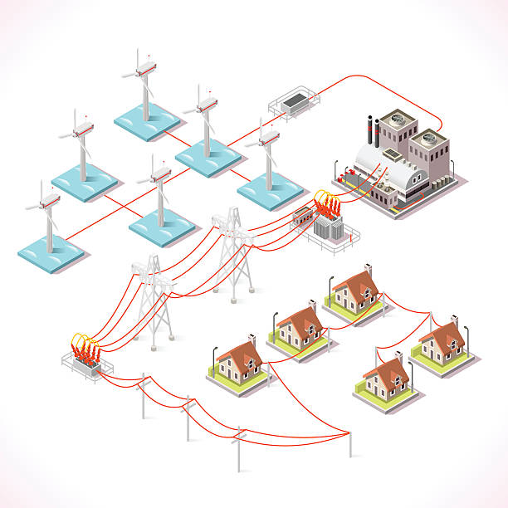

Figure II.1: Electricity grid.

I.3. Main parts of electric grid
In a very generic way, an electrical grid is always separated into four main parts:

I.3.1. Production:
It consists of the generation of all the active power consumed by the entire network. The vast majority of voltages associated with this production are produced in the form of three-phase systems via alternators driven from various types of so-called "primary" energy sources. Electrical energy is produced at the same time as it is consumed, so production must constantly adapt to consumption. As a result, the whole production, transport, use constitutes a complex system[4].

I.3.2. Transport
The interconnection that ensures energy exchange.

I.3.3. Distribution
Its role is to distribute the power to the consumers or consumers.

I.3.4. Control center
The flow of electricity through the power grid is controlled from several control centers throughout the country these control centers use computers and communication systems to enable the operators to monitor both the flow of electricity and the condition of power grid[5].

I.3.5. Consumption
The consumption of electrical energy in one territory is spread over many different electrical appliances.
I.4.Classification of nominal potentials levels in a network[6]
The nominal potential levels of a network can be classified into:
Very low voltage (VLV): voltages below 50 volts and more generally at 30 volts. They are used for electric toys and in very humid rooms.
Low voltage (LV): voltages from 50 to 1000 volts. They are used for domestic appliances and most industrial appliances.
Medium voltages (MV): voltages between 1 and 35 kV up to 60 kV. They are used for the supply and distribution of electrical energy, in medium distances and in industrial networks.
High voltages (HV): voltages from 60 to 220 kV. They are used for the transport of energy at high transits and over longer distances.
Very high voltage (VHT) networks: voltages equal to or greater than 400 kV. They were made necessary by the increase in the power to be transported over greater distances.

I.5. Elements of power system

I.5.1. Power transformers:

The primary functions of a transformer are voltage transformation and isolation. Owing to the bulky iron cores and heavy copper windings in the composition, a transformer is one of the heaviest and most expensive parts in an electrical distribution system. The size and weight of a transformer is primarily a function of the saturation flux density of the core material and maximum allowable core and winding temperature rise. The power throughput density is inversely proportional to frequency and hence increasing the frequency allows higher utilization of the steel magnetic core and reduction in transformer size[7].

I.5.2. Current transformers (CT):

The current transformers (CTs) should correctly supply the protective relays with a stepped-down fault current level[8].

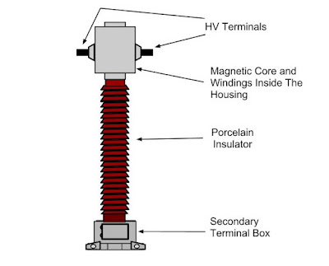

Figure II.2: Current transformers.

I.5.3. Potential transformers (PT):
A potential transformer (also known as voltage transformer) is a type of instrument transformer. It is a step-down voltage transformer that reduces the high-level voltage to safer low levels. The output voltage of the potential transformer can be measured by connecting an ordinary voltmeter[9].

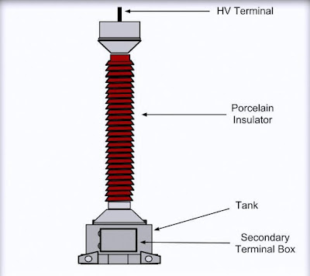

Figure II.2: Potential transformers.

I.5.4. Circuit breaker (CB):

The high-voltage (HV) Circuit breaker (CB) is one of the key components for controlling and protecting the power system. Due to its great number in the power network and strategic role in the successful operation of power systems , HV CBs’ failure would cause severe safety and financial damages[10].

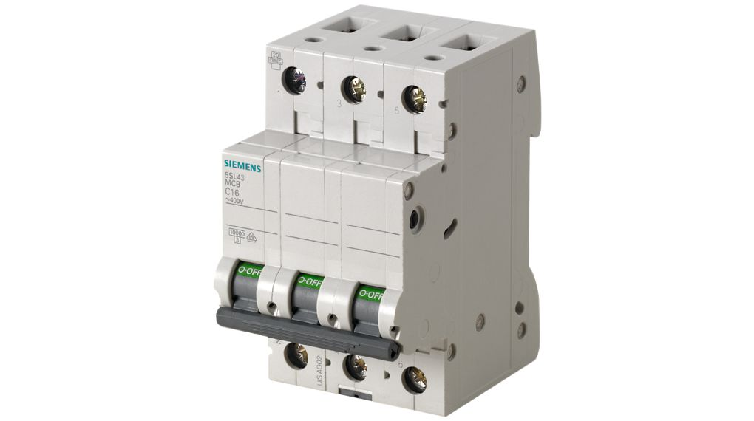

Figure II.3: Circuit breaker.

I.5.5. Isolators or Isolating switches:

Isolator is a manually operated mechanical switch that isolates the faulty section of substation. It is used to separate faulty section for repair from a healthy section in order to avoid the occurrence of severe faults. It is also called disconnector or disconnecting switch[11].

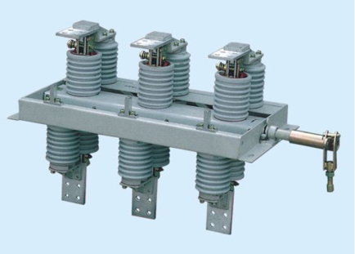

Figure II.4: Isolators or Isolating switches.

I.6. Electrical Substation
An electrical substation is a subsidiary station of an electricity generation, transmission and distribution system where voltage is transformed from high to low or the reverse using transformers. So, Sub-Stations are important part of power system. The assembly apparatus used to change some characteristics (e.g. voltage, AC to DC, frequency, Pf. etc.) of electric supply is called Sub-Station[12].
The following are the important points which must be kept in view while laying out a sub-station:
- It should be located at a proper site. As far as possible, it should be located at the center of gravity of load.
- It should provide safe and reliable arrangement. For safety, consideration must be given to the maintenance of regulation clearance, facilities for carrying out repairs and maintenance.
- It should involve minimum capital cost.[12]
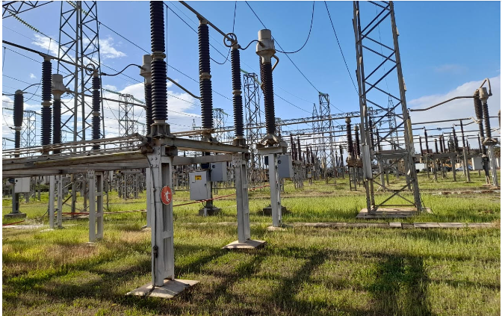

Figure II.5: Souffay Electrical Substation (original).

I.6.1. Transmission substation

The transmission substation is used as a transport medium between producer A and consumer B, not necessarily located in the same country. A and B have concealed a contract in which is stated that A produces a certain amount of energy and that B buys this energy. Hence, the contractual path of the electricity is straight from A to B. The physical path, however, is a group of parallel paths, some of which lead through countries that are not involved in the contract. In this manner, uncontrolled power flows can occur in the transmission system of a country and overload its lines[13].

I.6.1.1. Types of transmission lines
I.6.1.1.1. Overhead HV lines[14]
Rural areas with low load density are supplied by single-bypass overhead HV lines, which are traditionally less expensive than underground cables.
The design of these structures is linked to the maximum permissible voltage drops due to the distance of the loads to be served.

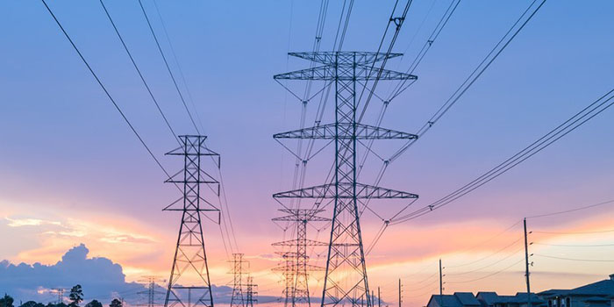

Figure II.6: Overhead High voltage transmissions lines.

I.6.1.1.2. Underground cables[15]
Currently, two types of cables are used on MV networks:
- Lead-insulated cables insulated with unipolar or three-core impregnated paper for the realization of the networks themselves.
- Synthetically insulated single-core cables for different special cases.
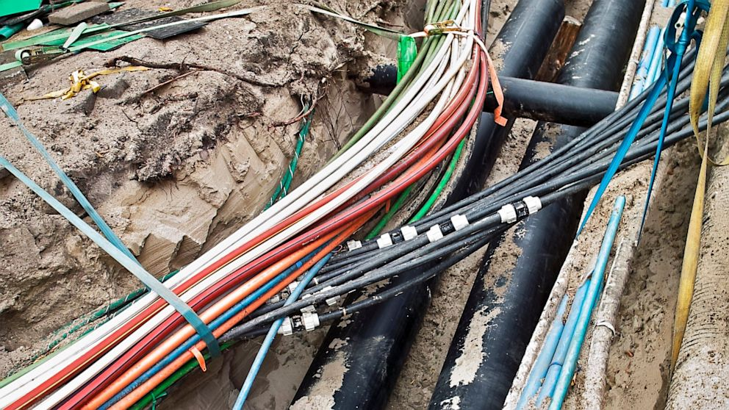

Figure II.7: Underground cables.

I.6.2. Distribution substation
A distribution substation transfers power from the transmission system to the distribution system of an area.
The input for a distribution substation is typically at least two transmission or sub transmission lines. Distribution voltages are typically medium voltage, between 2.4 and 33 kV depending on the size of the area served and the practices of the local utility[16].

I.6.2.1. Classification of power distribution system according connection schemes
An electric power distribution system can be classified according to its feeder connection schemes or topologies as follows:

I.6.2.1.1 Radial distribution system
In this case the energy is conveyed for radial path: That is to say from the source to the consumer. This means that any consumption point on such a structure can only be powered by one possible electrical path. It is of the tree type. This tree structure is carried out from the supply points, which are constituted by the public distribution stations HVB/HVA or HVA/HVA (distribution). This type of network is particularly used for the distribution of MV in rural areas. Indeed, it makes it easy to access consumption points with low load density and wide geographical distribution and for certain industrial networks with high disturbances[6].

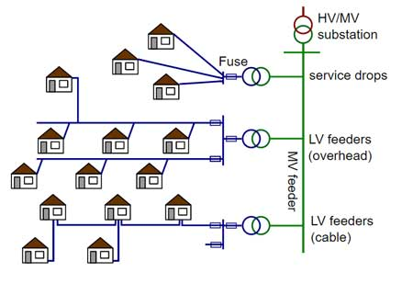
Figure II.8: Radial distribution system.

I.6.2.1.2. Ring main distribution system
These are networks where all the lines are looped thus forming a structure analogous to the meshes of a net, in addition, the number of sources flowing in parallel can reach several dozen. This structure requires that all line driving be able to withstand permanent overloads and that it be equipped at both ends with insulating devices in case of damage. This results in better security, but at a more expensive price[17].

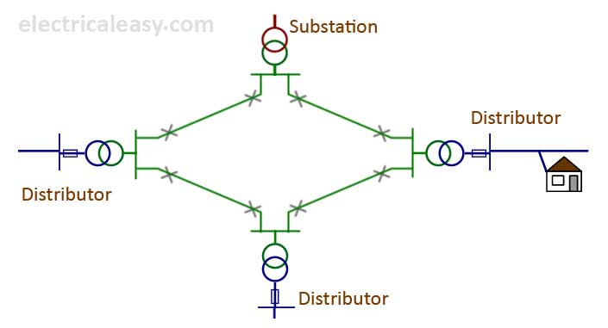

Figure II.9: Ring Main Distribution System.

I.6.2.1.3. Parallel feeders’ distribution
There is a disadvantage in radial feeders if there is any fault occur during the transmission there will be no supply for many customers so this can be changed by using parallel feeder if there is any fault occurs only one line of the feeder will be affected the other will do the work the cost is high due to increase in feeder number it can be used to transfer heavy loads
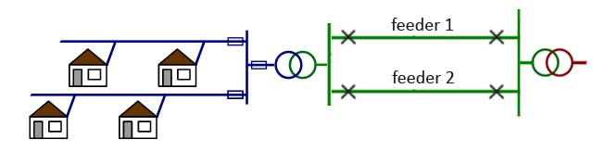

Figure II.10: Parallel feeders’ distribution.

I.6.2.1.3. Interconnected distribution [18]
When the feeder ring is energized by two or more than two generating stations or substations, it is called inter-connected system. Figure II.11 shows the single line diagram of interconnected system where the closed feeder ring ABCD is supplied by two substations S and S at points D and C respectively.
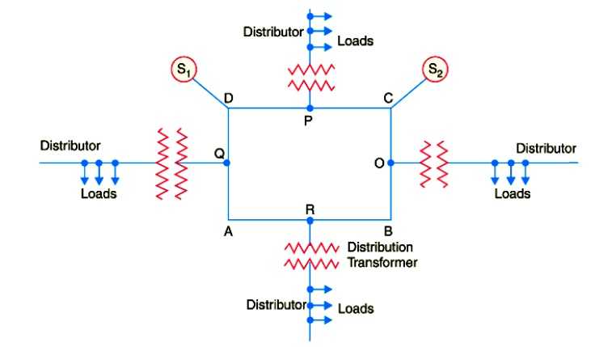

Figure II.11: Interconnected distribution.

I.7. Power system stability
Power system stability is the ability of an electric power system, for a given initial operating condition, to regain a state of operating equilibrium after being subjected to a physical disturbance, with most of the system variables bounded so that practically the entire system remains intact. The disturbances mentioned in the definition could be faults, load changes, generator outages, line outages, voltage collapse or some combination of these. Power system stability can be broadly classified into rotor angle, voltage and frequency stability. Each of these three stabilities can be further classified into large disturbance or small disturbance, short term or long term[19].
As electricity consumption varies across the day, the network has to be continuously balanced to maintain a constant voltage of 230 volts (V), largely with transformers. The grid uses alternating current which, at 50 hertz (Hz) means the flow direction of the current changes 100 times per second, equivalent to 3000 revolutions per minute. The specification of electrical appliances on the Island is therefore 230 V and 50 Hz. If the voltage differs by more than a few percentage or frequency by more than one percent then the appliances will fail[20].
Electrical current, voltage and frequency are all related meaning that significant variations in power supply can threaten grid stability. For this reason, grid protection systems operate to disconnect the supply if the limits are exceeded which would ultimately leading to electricity black-outs[20].

I.8. Classification of power system stability

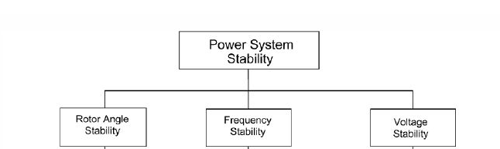

Figure II.12: Classification of power system stability.

I.8.1. Rotor angle stability
It is the ability of the system to remain in synchronism when subjected to a disturbance. The rotor angle of a generator depends on the balance between the electromagnetic torque due to the generator electrical power output and mechanical torque due to the input mechanical power through a prime mover. Remaining in synchronism means that all the generators electromagnetic torque is exactly balanced by the mechanical torque. If in some generator the balance between electromagnetic and mechanical torque is disturbed, due to disturbances in the system, then this will lead to oscillations in the rotor angle. Rotor angle stability is further classified into small disturbance angle stability and large disturbance angle stability[19].

I.8.2. Voltage stability
Voltage stability refers to the ability of a power system to maintain steady voltages at all buses in the system after being subjected to a disturbance from a given initial operating condition. It depends on the ability to maintain/restore equilibrium between load demand and load supply of the power system. Instability that may result occurs in the form of a progressive fall or rise of voltages at some buses. A possible outcome of voltage instability is loss of load in an area, or tripping of transmission lines and other elements by their protective systems leading to cascading outages. Loss of synchronism of some generators may result from these outages or from operating conditions that violate field current limit. Progressive drop in bus voltages can also be associated with rotor angle instability. For example, the loss of synchronism of machines as rotor angles between two groups of machines approach 180° causes rapid drop in voltages at intermediate points in the network close to the electrical center. Normally, protective systems operate to separate the two groups of machines and the voltages recover to levels depending on the post-separation conditions. If, however, the system is not separated, the voltages near the electrical center rapidly oscillate between high and low values as a result of repeated pole slips between the two groups of machines[21].

I.8.3. Frequency
Frequency is the number of cycles that alternating current makes in one second. It is measured in Hertz and must be maintained at a nominal value[22].

I.8.3.1. Alternating current
Electric power systems are almost exclusively based on alternating current (AC) at a unique frequency, e.g., 50 Hz in Europe and 60 Hz in North America. The “superiority” of AC systems over direct current (DC) ones to generate, transmit, and distribute electric energy has been under no discussion for about a century[23].
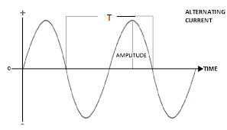

Fugure II.13: Alternating Signal.

I.8.3.2. Formula of frequency
The frequency is described by the following formula :
$f=\frac{1}{T}$ (II.1)
$f$is frequency (Hz)
$T$ is time periode(s)

I.8.3.3. Frequency of line voltage Ac motor
$f=\frac{Ns*p}{120}$ (II.2)

$Ns$ is synchronous speed(r/min)
$p$ is number of poles

I.8.3.4. Purpose of grid frequency
The grid frequency is the indicator for over- or under-generation of electrical power. It’s related to the rotation speed of the synchronized generators. If the energy consumption increases, the generators rotate more slowly, and with decreasing consumption, the rotation speed increases[24].

I.8.3.5. Importance of maintaining the frequency stable
The frequency must be maintained around the nominal value of 50 Hz, regardless of variations in consumption or production. Indeed, on the one hand, a constantly changing frequency would make electricity unusable for multiple uses, on the other hand, most components of the electrical system are designed to operate within a given frequency range, outside which serious equipment malfunctions can occur[25].
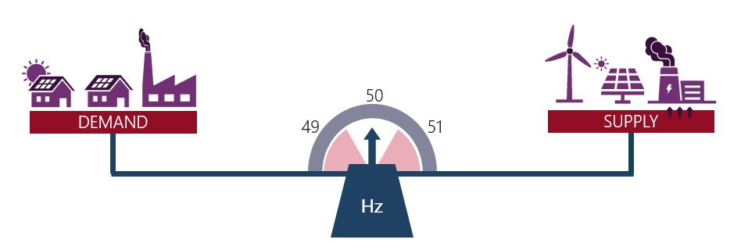

Figure II.14 : Balanced power fraquency.

I.8.3.6. Consequences of frequency deviation.
If the frequency goes too far away from this 50 Hz mark, the system can become unsafe, and generators and consumer might have to disconnect to protect themselves from any damage.
There are natural deviations in supply and demand that can cause frequency to go slightly above or below 50 Hz, which can be managed but there are also large disturbances in the system, such as a large power plant tripping off, which can severely affect the supply-demand balance and throw off the frequency of the system. To keep frequency close to 50 Hz, there are different lines of defense in our frequency control[26].
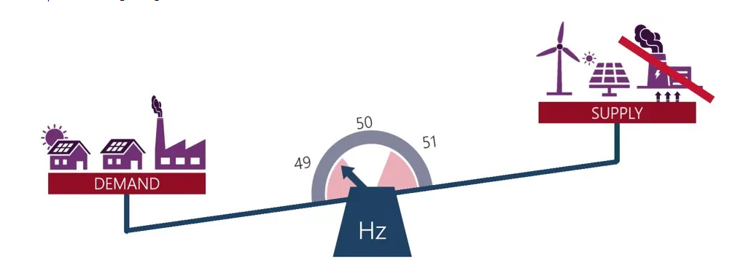

Figure.II.15: Negative balancing power frequency.

I.8.3.7. Frequency control in power system
Frequency variations in a power system occur because of an imbalance between generation and load. When the frequency value of a power system reaches the emergency condition, the control strategy is initiated. The frequency control is divided in three levels : primary, secondary and tertiary[27].
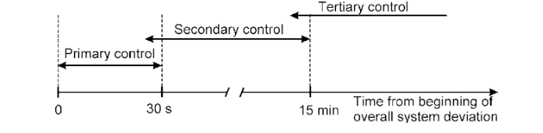
Figure II.16: Frequency control in power system.

I.8.3.7.1 Primary frequency control
The primary control makes it possible to return to a production-consumption balance. This is the component of the setting with the shortest response time: half of the primary reserve must be able to be mobilized in less than 15 s and the whole in less than 30 s. The primary control is implemented by the action of the speed regulators of the production units which generally act on the intake devices of the engine fluid to the turbine when the speed of the group (frequency image) deviates from the set speed as a result of an imbalance between the production and consumption of the entire synchronous interconnected system[22].

I.8.3.7.2. Secondary frequency control
Secondary control operates slower than primary control, in a timeframe of minutes. Its action becomes evident about 30 s after a disturbance/event, and ends within 15 min. Secondary control requires: a central regulator; a system measuring the interchanged power in tie-lines; measurements of the system frequency; and a system for transmission of regulator signals to the relevant generating units[28].

I.8.3.7.3. Tertiary frequency control [29]
TERTIARY CONTROL is any automatic or manual change in the working points of generators or loads participating, in order to:
- Guarantee the provision of an adequate SECONDARY CONTROL RESERVE at the right time.
- Distribute the SECONDARY CONTROL POWER to the various generators in the best possible way, in terms of economic considerations.
Changes may be achieved by:
- Connection and tripping of power (gas turbines, reservoir and pumped storage power stations, increasing or reducing the output of generators in service);
- Redistributing the output from generators participating in secondary control;
- Changing the power interchange program between interconnected undertakings;
- Coad control (e.g., centralized telecontrol or controlled LOAD-SCHEDDING).

I.8.3.8. Impacts of wind energy on the frequency of the electricity grid
Rapid variations in the power generated by wind turbines (which can reach a few hundred kW in a few tens of seconds) as well as load variations, can therefore induce fluctuations in the frequency of the network and activate the primary adjustment of the rotating units and call on the primary reserve. However, as long as wind penetration remains low, this influence can be considered negligible. Otherwise, in order to ensure the stability of the network, participation in the primary regulation of wind turbines will be considered with solutions that remain to be imagined. Already currently, when production is higher than consumption, so when the frequency is greater than 50Hz, wind turbines can be asked to reduce their production[22].

I.9. Conclusion
In the first part of this chapter, we defined and presented the different structures and materials used in electrical networks.
A second part was devoted to the different types of stability in the network electric.
The last part is devoted to the variation of the frequency, the different types of the variation, grid frequency regulation and the impact of wind energy on the power grid frequency.
Furthermore, to overcome this problem and recommend appropriate solutions to avoid states of instability and ensure quality energy, frequency supervision turns out to be necessary.
Thus, in the following chapter we will present the ARDUINO card that will be used for realization of the frequency supervisor.

Chapter II
Arduino and other components

Chapter II:
Arduino and other components

II.1. Introduction

The word Arduino refers to three separate tools, which, bundled together, create the toolkit that we refer to as Arduino. First, there is the Arduino controller, which exists in several forms, from large too small to a freely available schematic that anyone with the requisite knowledge can assemble for about $22 equivalent to 6800Da. Second, there is the language and compiler, which creates code for this microcontroller, and which, much like the Processing language, simplifies many of the tasks that challenge designers and developers alike when working with hardware and physical interaction. Finally, there is the Arduino programming environment, which, again like the Processing IDE, is a simple open source IDE built in Java[30].
Arduino is an open source, micro controller-based hardware platform, and software IDE (integrated development environment), which can be used to write code to manipulate the hardware[31].

II.2. A brief story of arduino.
In 2005, the Arduino project was initiated at the Interaction Design Institute Ivrea in Ivrea, Italy. Its primary objective was to offer an affordable and user-friendly tool for both beginners and experts to develop devices that could interact with the surrounding environment through sensors and actuators.

II.3. Arduino module definition
An Arduino board is equipped with a microcontroller that can be programmed to interpret and generate electrical signals.

II.3.1. Printed circuit board
It is a kind of plate on which are welded several electronic components connected to each other by a more or less complicated electrical circuit. The Arduino is therefore a printed circuit board[32].

II.4. Microcontroller
A microcontroller, often referred to as an MCU or microcontroller unit, is a compact computer housed on a single integrated circuit chip. It consists of one or more CPUs (processor cores), as well as memory and programmable input/output peripherals.
A microcontroller (MCU for microcontroller unit) is a small computer on a single metal-oxide-semiconductor (MOS) integrated circuit (IC) chip. A microcontroller contains one or more CPUs (processor cores) along with memory and programmable input/output peripherals.
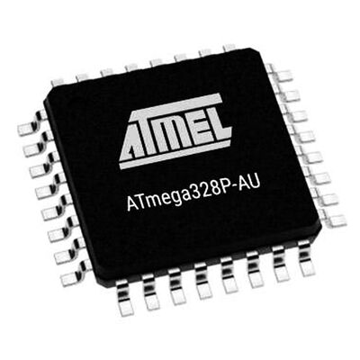

Figure II.1: ATmega328P-AU microcontroller.

II.5. Elements of arduino board
The elements in Arduino are divided in two categories:
a) Hardware
b) Software

II.5.a). Hardware
The Arduino board is a small microcontroller board, which is a small circuit (the board) that contains a whole computer on a small chip (the microcontroller)[33].
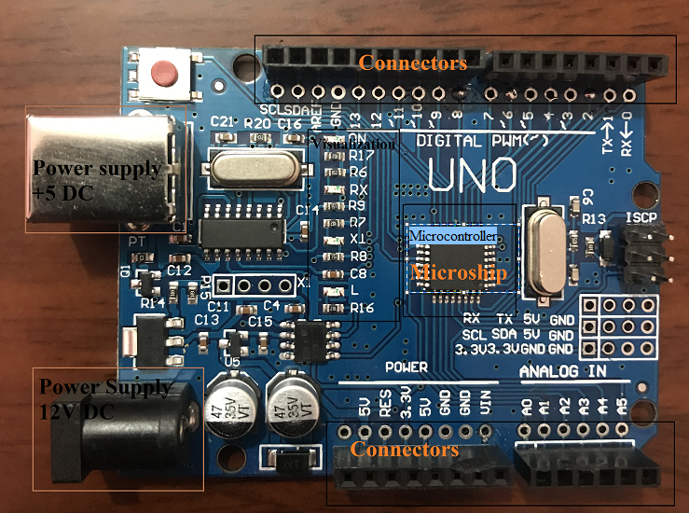

Figure.II.2: Hardware parts of Arduino.

II.5.a).1. The most crucial parts of arduino

II.5.a).2. The microcontroller
Upon receiving the program, the microcontroller will store it in its memory and subsequently execute it.

II.5.a).3. Power supply
To work, the board needs a power supply. The microcontroller operating at 5V, the board can be powered in 5V by the USB port or by an external power supply (in 3) which is between 7V and 12V. This voltage must be continuous and can for example be supplied by a 9V battery. A regulator is then responsible for reducing the voltage to 5V for the proper functioning of the board [29].

II.5.a).4. Visualization
The three "white dots" surrounded in red are LEDs whose size is of the order of a millimeter. These LEDs are used for two things:
- The one at the top of the frame: it is connected to a pin of the microcontroller and will be used to test the hardware. Note: When the card is connected to the PC, it flashes for a few seconds.
- The two LEDs at the bottom of the frame: are used to visualize the activity on the serial channel (one for transmission and the other for reception). Downloading the program into the microcontroller doing through this way, they can be seen flashing when loading.

II.5.a).5. The connectors
The Arduino board does not have components that can and reuse for a program, put by the LED connected to pin 13 of the microcontroller, it is necessary to add them. But to do this, they must be connected to the card (connectors). It is thanks to this connector that the board is "expandable", because you can connect all types of assemblies and modules! For example, the Arduino Uno board can be extended with Shields, such as the ≪ Shield Ethernet ≫ which allows you to connect the latter to the internet.

II.5.b). Arduino software[34]
The Arduino IDE is an open-source software, which is used to write and upload code to the Arduino boards. The IDE application is suitable for different operating systems such as Windows, Mac OS X, and Linux. It supports the programming languages C and C++. Here, IDE stands for Integrated Development Environment.

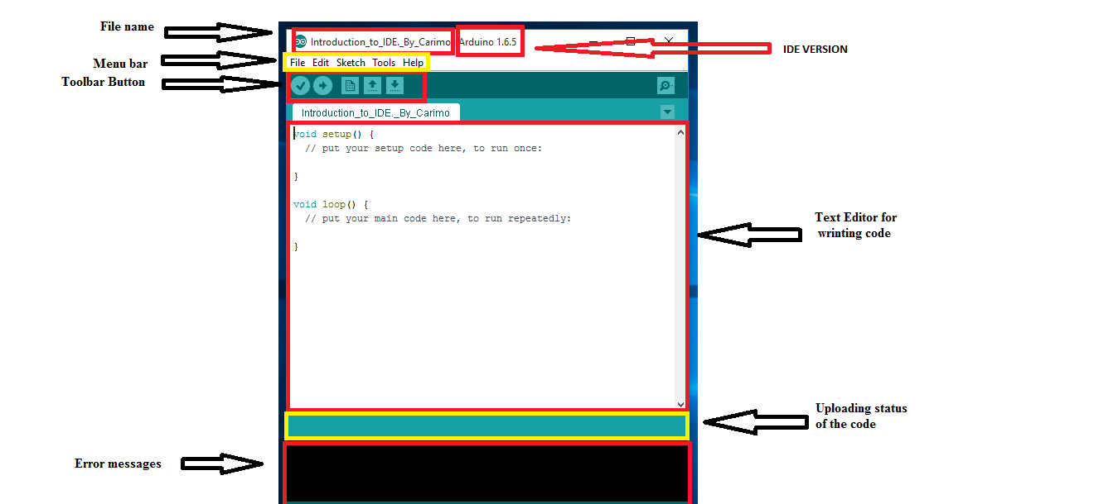

Figure II.3: Arduino IDE Software.

- File name
The file name option it allows us to attribute a desired name to our code or Sketch.
- Menu bar
The menu bar it is composed by: File, Edit, Sketch, Tools, Help. And each of these Icons contains another sub icon.

Example of a drop down list after clicking in the button File .
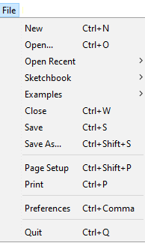

Figure II.4: Icon file.

The list shown below has a lot of icons and each with its specific functionality.
- Tool Button
The icons displayed on the toolbar are New, Open, Save, Upload, and Verify.
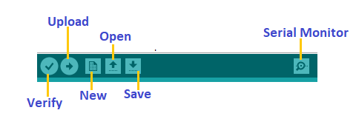

Figure II.5: Icon of Toll Button.

Verify: the icon verify help us to check if our sketch or code contain errors
Upload: after verifying our code or sketch we can upload it, by using the icon upload.
New: in case of wanting to start a new sketch this is the icon that we should click on.
Open: the utility of this icon is to open an existing code or Sketch.
Save: when we are done writing our code we can and checked if it doesn’t contain an error we can store using the icon save.
Serial monitoring: it shows the status of the code which is being rune.

II.6. Most common used types of Arduinos [35]

II.6.1. Arduino UNO
Arduino Uno is the most popular and widely used development board. It is powered by an ATMega328P microcontroller. It is the most popular choice among the community because it’s, cheap, easy to learn and use, and also a variety of premade modules are available for this which makes it easier for developing new projects or prototypes. It consists of 14Digital I/O out of which 6 pins are 8bit PWM pins, 6 pins are10-bit Analog inputs, and basic communication ports like SPI, I2C, and UART.
Now, there are many different types of Arduino UNO boards available across the global market, but most of these boards are the clone or copy version of the original UNO board that you see above. Hence the color or the appearance of the board might be different than what is shown above.

II.6.2. Arduino nano
Arduino Nano is a small breadboard-friendly version of Arduino UNO. It has more or less functionality of the Arduino UNO but in a small form factor. The only major differences from UNO are the lack of a DC power jack, the usage of a Mini USB port instead of a USB B port, and the USB-TTL converter chip. Nano uses an FT232, a dedicated USB-UART bridge chip from FTDI instead of an ATMega16U2. It is also a very popular choice among the developers just like UNO because of its small size and cheap price.
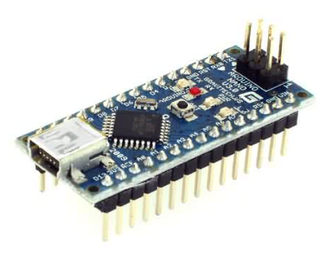

Figure II.6 : Arduino nano.

II.6.3. Arduino Mega
Arduino Mega 2560 is the biggest of all the boards we have discussed so far. It is designed for applications where a lot of I/O or peripherals are needed. It is powered by a bigger and more capable processor the ATMega2560. This board has the greatest number of I/O than most other boards, 54 I/O pins (of which 15 can be used as PWM outputs), 16 analog inputs, and 4 UARTs. It has more flash storage and SRAM than most other basic Arduino boards. It is most popular with the open-source CNC and 3D printer community as well as the open-source PLC community.
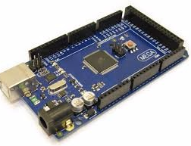

Figure II.7: Arduino Mega2560.

II.7. Advantantages of arduino [33]
- It is a multiplatform environment; it can run on Windows, Macintosh, and Linux.
- It is based on the Processing programming IDE, an easy-to-use development environment used by artists and designers.
- You program it via a USB cable, not a serial port. This feature is useful, because many modern computers don't have serial ports.
- It is open-source hardware and software if you wish, you can download the circuit diagram, buy 21 all the components, and make your own, without paying anything to the makers of Arduino.
- The hardware is cheap. The USB board costs about €20 (currently, about US$35) and replacing a burnt-out chip on the board is easy and costs no more than €5 or US$4. So, you can afford to make mistakes.
- There is an active community of users, so there are plenty of people who can help you.

II.8. Components used to make the circuit of frequency meter

II.8.1. 1N4007 Diode
A 1N4007 is a widely used general purpose diode. It is normally built to use as rectifier in the power supplies section of electronic appliances for converting AC voltage to DC with other filter capacitors. It is a diode of 1N400x series in which there are also other similar diodes from 1N4001 to 1N4007 and the only difference between them is the max repetitive reverse voltage.
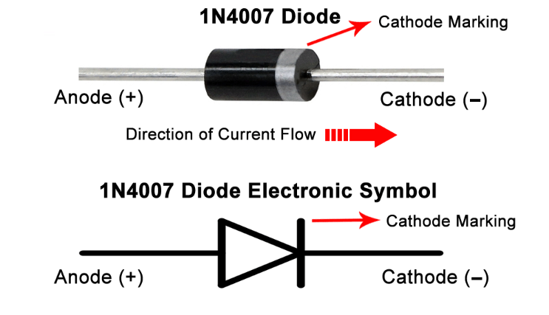

Figure II.8: 1N4007 diode.

II.8.2 Generic electrolytic capacitor
The capacitance is the capacity of a dielectric system to contain electrostatic charge, defined by the ratio Q/V where Q is the electric charge that the capacitor is capable of storing at the applied voltage V. The unit of capacitance is the "farad", and the charge is "coulomb".
The electrolytic capacitor is a form of polarized capacitor.
The electrolytic circuit symbol indicates the polarity as it is essential to ensure that the capacitor is fitted into the circuit correctly and is not reverse biased.
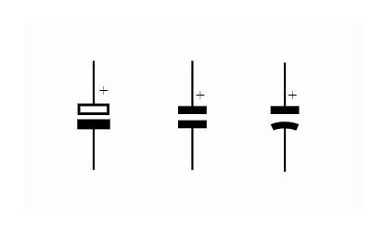

Figure II.9: Symbols of polarized capacitor.

II.8.3. Resistor
Resistor is a two-terminal device that is used to resist the flow of electricity or current. A resistor has no polarity. Resistance (also known as ohmic resistance or electrical resistance) is a measure of the opposition to current flow in an electrical circuit. The basic unit of electrical resistance is the Ohm. This is often denoted by the Greek symbol omega (Ω). The value of resistance for conductors is less whereas for insulators it is more. Resistance plays a major role in Ohm’s Law[36].
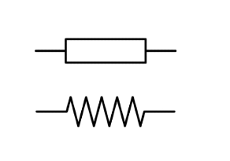

Figure II.10: Symbol of resistor.

II.8.4. DS3232 RTC Module
The DS3232 is a low-cost temperature-compensated crystal oscillator (TCXO) with a very accurate, temperature-compensated, integrated real-time clock (RTC) and 236 bytes of battery backed SRAM. The RTC maintains seconds, minutes, hours, day, date, month, and year information.

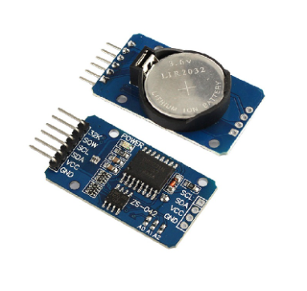

Figure II.11: DS3232 RTC module.

II.8.5. SD CARD
The module (MicroSD Card Adapter) is a Micro SD card reader module, drive programming through the file system and the SPI interface. Single chip system can complete the MicroSD card reading and writing files. Arduino users can directly use the Arduino IDE built-in SD card library to complete the card initialization and read and write.
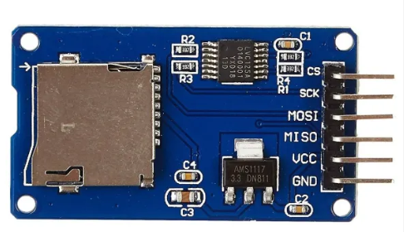

Figure II.12: SD Card.

II.8.5. Liquid Crystal Display 16x2
This LCD is called 16x2 because you can write 16 characters or numbers in column wise and 2 in row wise. This display has total of 16 pins
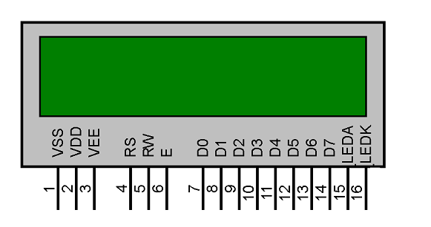

Figure II.13: Liquid Crystal Display 16x2.

II.8.6. PCF8474 I2C Module
I²C (Inter-Integrated Circuit; pronounced as “Eye-Squared-C”), alternatively known as I2C or IIC, is a synchronous, multi-master/multi-slave (controller/target), packet switched, single-ended, serial communication bus invented in 1982 by Philips Semiconductors.
IIC/I2C Interface Adapter Module is used for 16x2 LCD Display. It uses PCF8574 IC chip which converts I2C serial data to parallel data for the LCD display. Also, this interface module simplifies connecting an arduino to a 16x2 Liquid Crystal display using only 4 wires. It provides general-purpose remote I/O expansion for most micro-controller families via the I2C interface (serial clock, SCL, and serial data, SDA, pins).

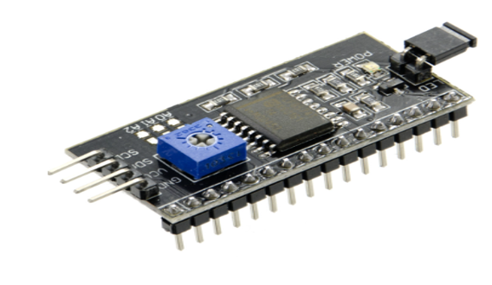

Figure II.14: PCF8474 I2C Module.

II.8.7. PC817 Optocoupler
An optocoupler is a simple electronic component that is used to connect separate circuits together by the means of a light-sensitive optical interface. An optocoupler or optoisolator consists of a light emitter, the IR LED, and a light-sensitive receiver which can be a single photo-diode, photo-transistor, photo-resistor, photo-SCR, or a photo-TRIAC. Optocoupler testers are used to check the functionality of any optocoupler receiver.

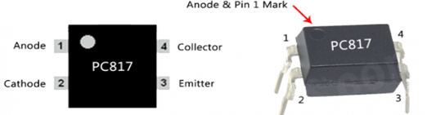

Figure II.15: PC817 Optocoupler.

II.8.8. Sep-down transformer 220v to 12v/9v
A transformer is a type of static electrical equipment that transforms electrical energy (from primary side windings) to magnetic energy (in transformer magnetic core) and again to the electrical energy (on the secondary transformer side).
A step-down transformer is a type of transformer that converts the high voltage (HV) and low current from the primary side of the transformer to the low voltage (LV) and high current value on the secondary side of the transformer.

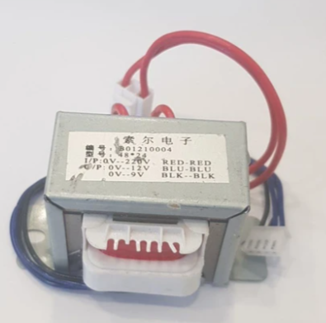

Figure II.16: Step down transformer 220v to 12v and 9v.

II.8.9. Buzzer
An audio signaling device like a beeper or buzzer may be electromechanical or piezoelectric or mechanical type. The main function of this is to convert the signal from audio to sound. Generally, it is powered through DC voltage and used in timers, alarm devices, printers, alarms, computers, etc. Based on the various designs, it can generate different sounds like alarm, music, bell & siren
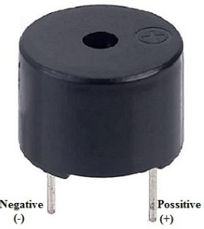

Figure II. 17: Buzzer.

II.8.10. 5V Relay module [37]
A 5v relay is an automatic switch that is commonly used in an automatic control circuit and to control a high-current using a low-current signal. The input voltage of the relay signal ranges from 0 to 5V.
The relay module with a single channel board is used to manage high voltage, current loads like solenoid valves, motor, AC load & lamps. This module is mainly designed to interface through different microcontrollers like PIC, Arduino, etc.
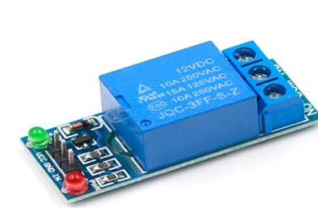

Figure II. 18: 5V relay Module.

II.8.11. Tactiles 12x12 button [38]
Tactile Switches or tact switches are an on/off electronic switch that is only on when there is some pressure put on it or when the button is pressed. As soon as the tactile switch button is released and the pressure has been taking off, the circuit is then broken.
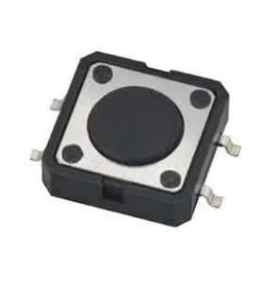
Figure II.18: 12x12 tactile button.

II.9. Conclusion
In this chapter, was given an overview of the components that were needed for the fabrication of the frequency meter.
And it is important to point out that in this project the type of Arduino used was the UNO.
In the next chapter the main focus will be on the simulation and realization of frequency meter.

Chapter III
Simulation and realization

III.1. Introduction

For the realization of any project, it is always important to do the simulation before, because it will give us an idea of how our desired circuit or device will perform. And for this dissertation it is not going to be different because the software called Proteus version 8.9 Professional, will be used to simulate the circuit or device.
In this chapter a grid frequency meter based on the Arduino will be made. Which is going to allow us to control the power line frequency, beside this it composed by a data login (RTC DS3231 module for the real time and SD CARD for the storage of the daily frequency variation), meaning that it will allow us to extract the variation of frequency in time and store it in the SD CARD which contain a micro memory card, so that late on we can build chart using excel, for the purpose of analyzing the frequency defaults. It also contains a relay which will allow us to cut our any circuit connected to it. The main utility of the relay, it for the protection.

III.2. Proteus
It is a circuit designing software invented by Labcenter Electronics. It used to design different circuits on PCB (printed circuit board) and simulation of different circuits. The use of proteus for any electronic circuit project makes that project cost-effective and reduces error due to schematic construction on the proteus.
In 1988 the first version of Proteus known as PCB-B was created by John Jameson who was chairman of the company. In today’s post, we will have a detailed look at its uses, structure, and will learn how to make different circuits in Proteus[39].
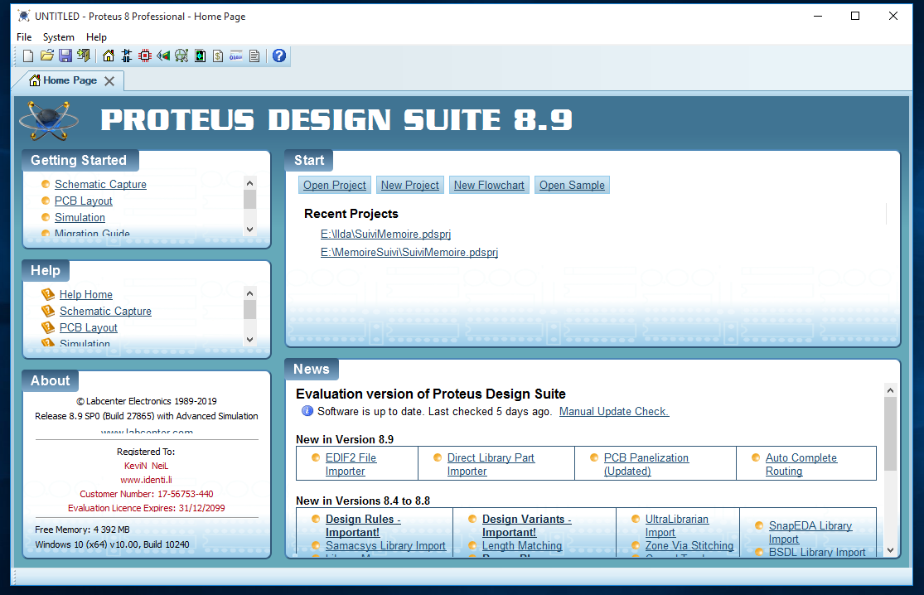

Figure III.1: Proteus 8.9 professional.

It is a software containing Schematic, Simulation and PCB designing.

III.2.1 ISIS:
ISIS abbreviation is Intelligent Schematic Input System. ISIS is used to draw schematic and simulate the circuit in real time. The Simulation allows human access during run time, providing real time simulation[40].

III.2.2. ARES:
ARES Stands for Advance Routing and Editing Software. ARES is used for PCB designing. It has the feature of viewing 3D view of the designed PCB along with components. The designer can also develop 2D drawings in it[40].

III.3. Simulation of the circuits of the frequency meter using Proteus 8.9

III.3.1. First circuit:
This is a simple frequency meter, meaning that its function is just to monitor the frequency. It was made after several researches were done.

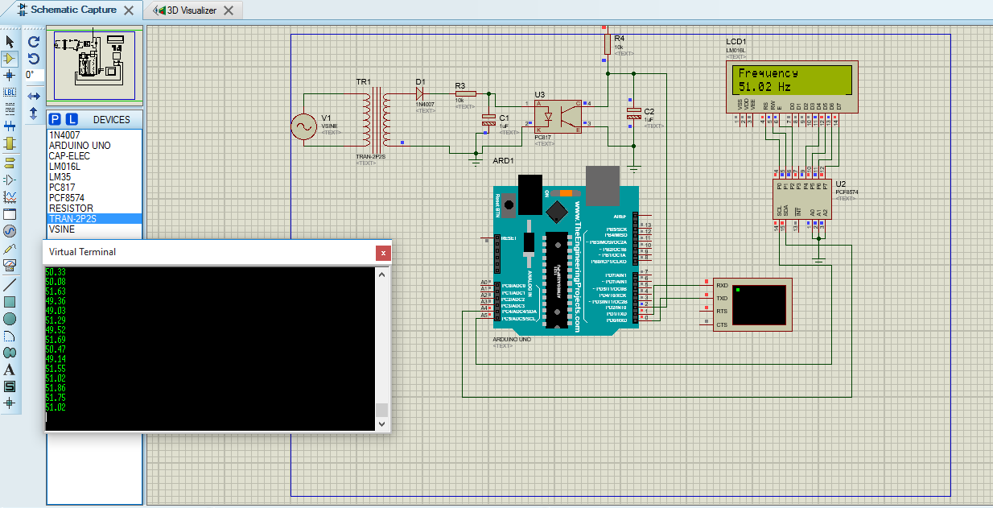

Figure III.2: Simple frequency meter.
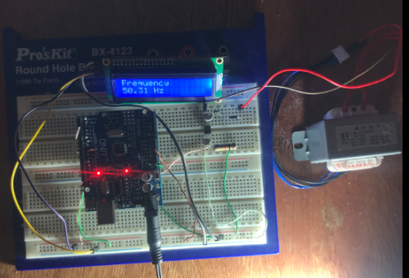

Figure III. 3: Image of the simple frequency meter.

III.3.2. Second circuit: Improved frequency meter by adding the buzzer
When the simulation and the realization of the first frequency meter was done, it was seen that the same, was very simple, and as mentioned earlier, its function is just to monitor the frequency. So, a buzzer was added in it. Since it is known that by specification standards, the frequency should be within a specific band. And in some countries the band is within +/-3% meaning, 48.5 to 51.5 Hz. In this circuit a buzzer was added, and the same is going to work as alarm when the grid frequency is out of range or band.

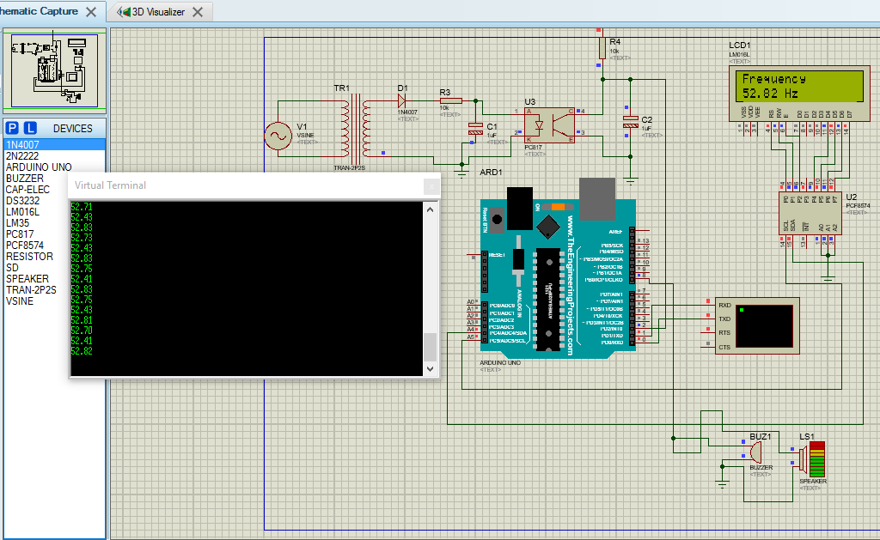

Figure III. 4: Frequency meter with buzzer integrated in it.

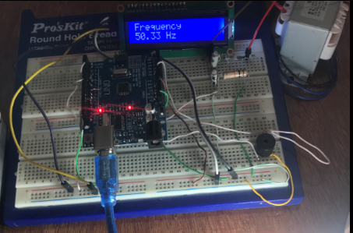

Figure III. 5: Image of frequency meter with buzzer integrated in it.

III.3.3. Third circuit: Frequency meter with buzzer and 5v Relay
There many different electronic components designed to be controlled with the use of Arduino, and after it was seen that the second frequency meter was just alerting us by ringing in case of our grid frequency going out of range, a 5V relay module and a push button were added, which are going to allow the interruption of the grid station in case of the grid frequency going out of range.

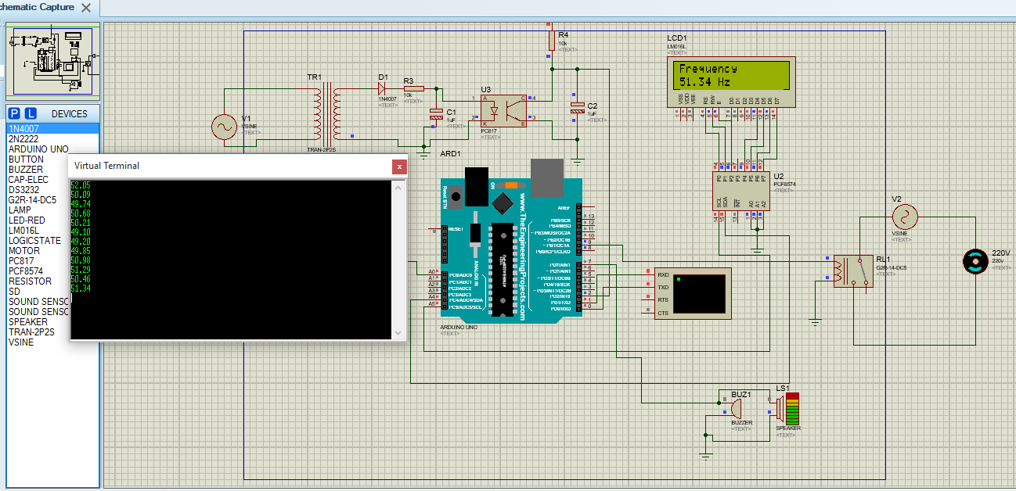

Figure III.6: Frequency meter with 5V relay, buzzer and push button.

III.3.4. Fourth circuit: Frequency meter with data login
The fourth frequency meter, it is composed by a data login system, in other words, it has a SD card and DS3231 RTC module. With this frequency meter we can store our frequency information, so that later on, in case wanting to evaluate our frequency, we can take the information stored and create Charts with Excel.

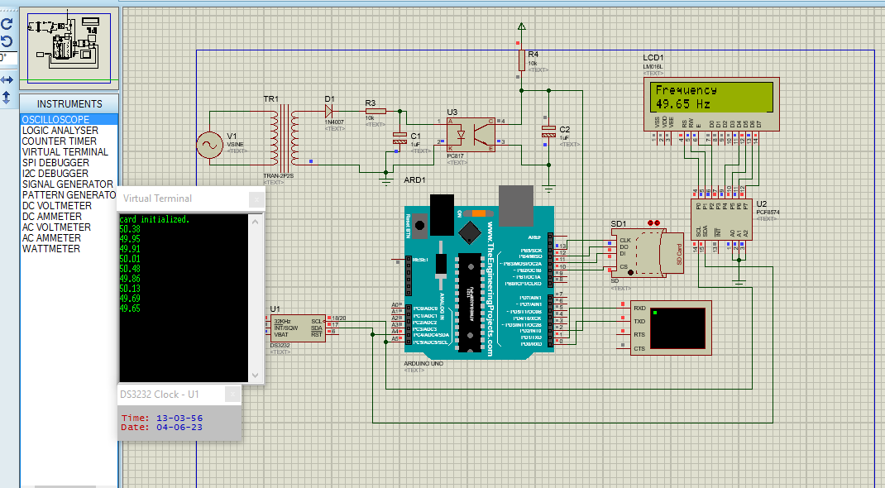

Figure IV.7: Frequency meter with data login.
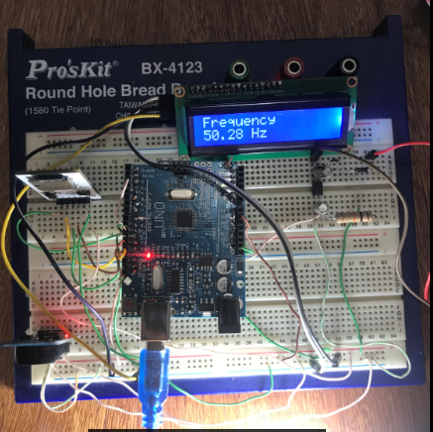

Figure III.8: Image of frequency meter with data login.

III.3.5. Final or fiftieth circuit: Combination of the previous circuits
When the simulation and realization of the previous circuits was done, an idea of combining the previous circuits to make one and sophisticated frequency meter came up. The combination of these circuits will make the frequency meter able to do multiple functions. And here it is. A frequency meter with a data login system, alarm, and power cut system.

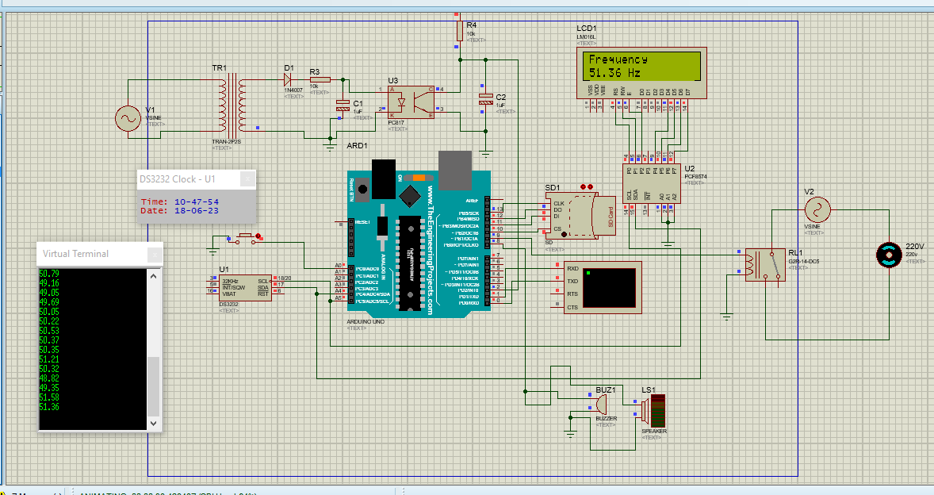

Figure III. 9: Final frequency meter.

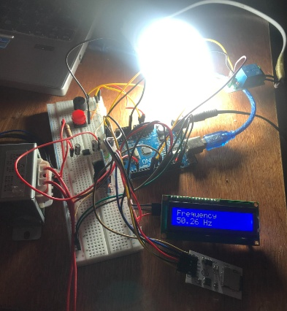

Figure III.10: Image of the final frequency meter.

III.6. Graphs of the signals in proteus
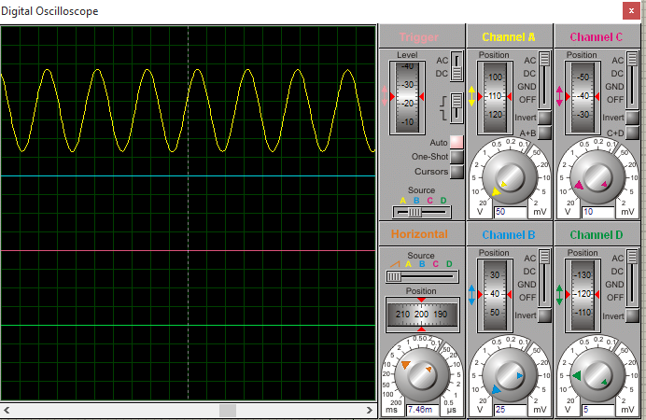

Figure III.11: Graph of 220v AC signal.

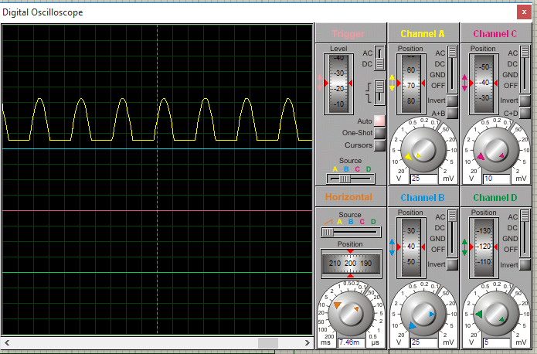
Figure III.12: Graph of the halfwave bridge rectifier
III.7. Verification of the signals in Oscilloscope
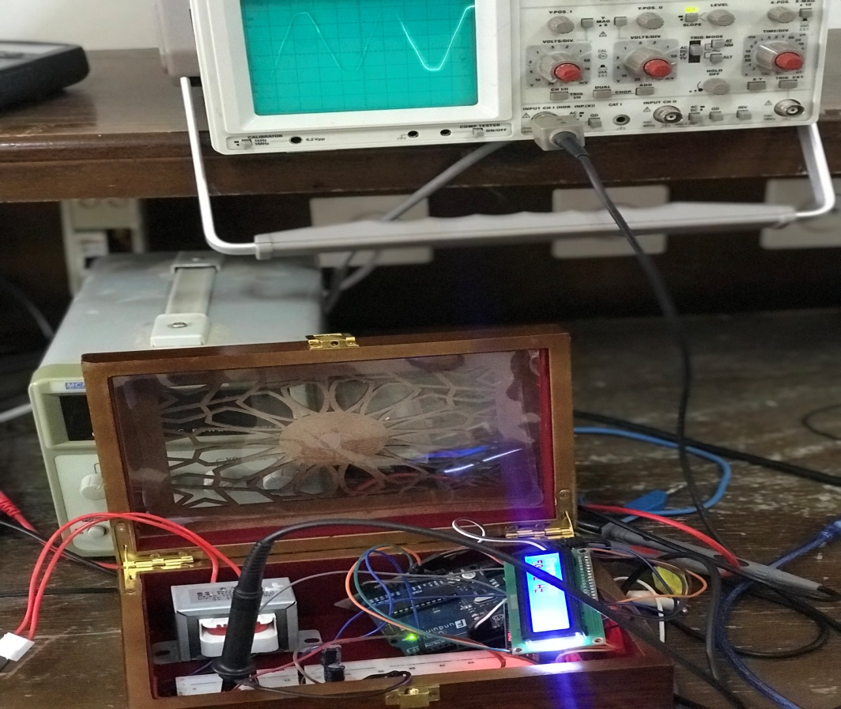
Figure III. 13: Verification of the AC signal in the circuit.
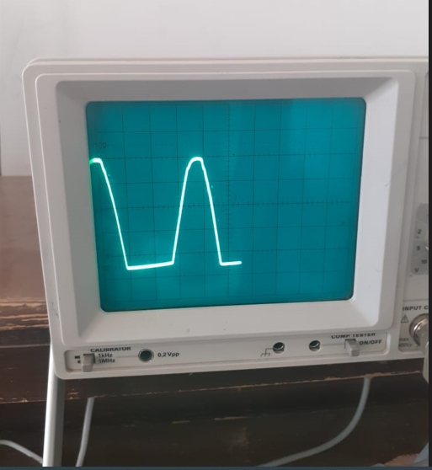

Figure III.14: Verification of the signal of after Half-Wave Rectifier.

Table III.1: Collected Frequency data.
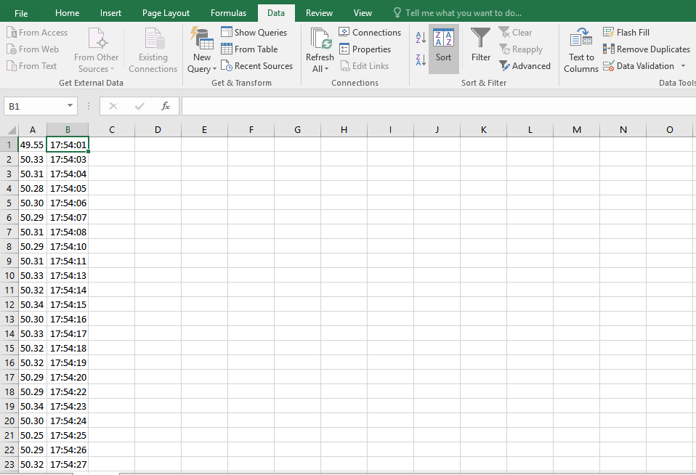

As we can see in the table above, we have data of frequency in column A and Time in column B, this information was extracted from the micro memory card in our frequency meter.

Table III.2: Tables of connections SD card to Arduino.
SD Card | Arduino UNO
MISO | D12
MOSI | D11
SCK | D13
CS | D10
VCC | +5V
GND | GND

Table III.3: Table of connections between DS3131 RTC Module and Arduino Uno.

DS3131 RTC Module | Arduino UNO
SDA | A4
SCL | A5
VCC | +5V
GND | GND

Table III.4: Table of connections between I2C Module Liquide Crystal and Arduino.

I2C Module Liquide Crystal | Arduino
SDA | A4
SCL | A5
VCC | +5V
GND | GND

Table III.5: Connections between 5V relay module and Arduino.

5V RELAY MODULE | ARDUINO
IN | PIN 7
GND | GNG
VCC | +5

III.8: Connections of the buzzer to Arduino
The positive of buzzer is connected to pin 8 of the arduino, and the GND in connected to the GNG
III.9: Connections of the push button to Arduino
The one leg of the push button is connected to Pin A0 of the Arduino the other one is connected to the GND.

III.10: Circuit designed using the EasyEDA, for the conception of PCB( Printed Circuit Board)
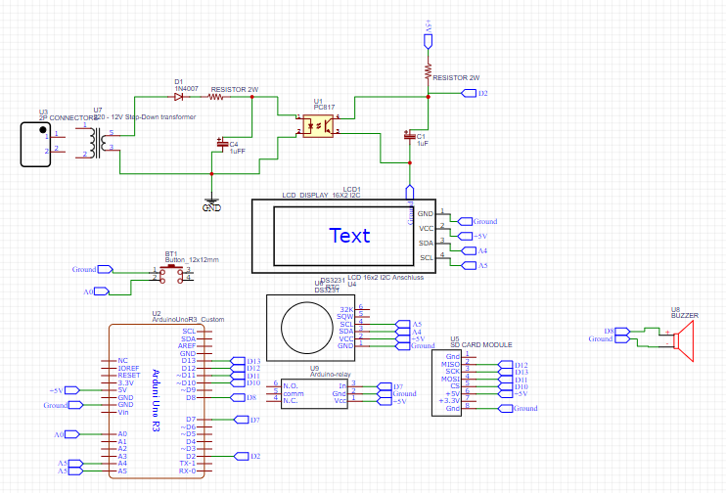

Figure III. 15: Circuit for my complex frequency meter.

III.11: Scheme of trace tracking in PCB

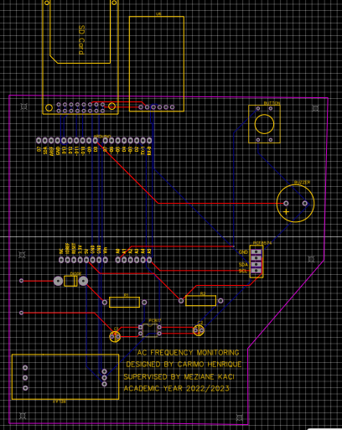

Figure III.16: Scheme of trace tracking.

III.12: 3D view of the previous scheme

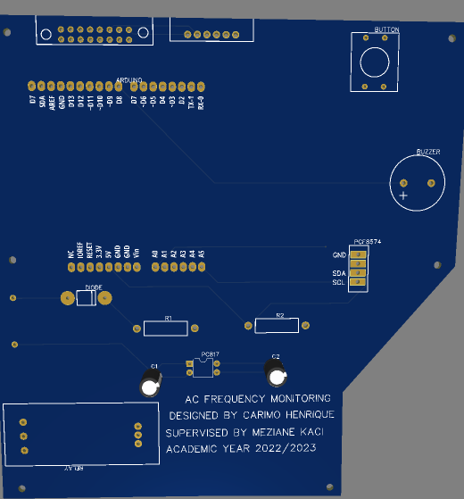

Figure III.17: 3D view of the PCB.

III.13. Conclusion

In this chapter we presented the simulation and the practical realization of frequency meter as well as the validation of the results obtained, which enabled us to confirm, the reliability of this project.

General Conclusion

General conclusion

In the first chapter, we described the various elements of an electrical network, then the study of the variation of the frequency in electrical network.
In the second chapter, we presented the principle of the Arduino microcontroller and the different elements that constitute it as well as other components.
In the last chapter, we achieved the objective of the dissertation, which was to design and produce a frequency meter that will monitor the frequency of an electrical network using an ARDUINO UNO card. The advantage of using an ARDUINO UNO card is that it not expensive. In addition to its simplicity of use.
The designed and produced frequency meter it is divided in three parts. The first one is for data logging (this will allow us to store data of the frequency). The second part is for alarm system (in case of the grid frequency going out of range, a buzzer will start ringing) and third part is for power cutting (this part has a 5V relay module which is commended by a switch button). It important to point out that, the possibility of not using the push button to control the 5V relay exist, but this requires a sound captor.
The utility of the sound captor in the perspective of this project, it the captor the sound of the buzzer, and cut the power automatically.
Since it is known that when the frequency in power grid goes out of range, the possibility of electronic components getting destroyed it is very high.
The use of Bluetooth communication is an economy advantage on the one hand and allows us to avoid the problems produced by the USB Cable on the other hand.

Bibliography

[1] Chessmore DT. Voltage Profile Estimation And Reactive Power Control Of Distribution Feeders, https://rc.library.uta.edu/uta-ir/handle/10106/975 (2008, accessed 23 May 2023).
[2] Nakarmi U. Reliability Analysis of Power Grids and its Interdependent Infrastructures: An Interaction Graph-based Approach.
[3] Xi D, Hu L, Li X. Power Grid and Alternating Current Distribution Research of Renewable Energy Generate Electric Power’s Village System. Energy Procedia 2011; 12: 328–334.
[4] MOULOUDJ A, CHIBANE A. Contrôle intelligent du réseau électrique équipé d’une ferme éolienne.
[5] Abbes M. Smart grid and renewable energy in Algeria. IEEE, 2017, pp. 1166–1171.
[6] DJEBAIRIA Sabra HR. Amélioration de la qualité de l’énergie électrique. Université 8Mai 1945–Guelma, 2021.
[7] Manjrekar MD, Kieferndorf R, Venkataramanan G. Power electronic transformers for utility applications. In: Conference Record of the 2000 IEEE Industry Applications Conference. Thirty-Fifth IAS Annual Meeting and World Conference on Industrial Applications of Electrical Energy (Cat. No.00CH37129). 2000, pp. 2496–2502 vol.4.
[8] Esmail EM, Elkalashy NI, Kawady TA, et al. Detection of Partial Saturation and Waveform Compensation of Current Transformers. IEEE Transactions on Power Delivery 2015; 30: 1620–1622.
[9] Technology E. Potential Transformer (PT) - Types of Voltage Transformers. ELECTRICAL TECHNOLOGY, https://www.electricaltechnology.org/2021/09/voltage-potential-transformer.html (2021, accessed 30 May 2023).
[10] Hu W, Westerlund P, Hilber P, et al. A general model, estimation, and procedure for modeling recurrent failure process of high-voltage circuit breakers considering multivariate impacts. Reliability Engineering & System Safety 2022; 220: 108276.
[11] Satpathy R, Pamuru V. Chapter 10 - Grid integration, performance, and maintenance of solar PV power systems. In: Satpathy R, Pamuru V (eds) Solar PV Power. Academic Press, pp. 435–481.
[12] Thesis On Electrical Substation. The Lawyers & Jurists, https://www.lawyersnjurists.com/article/thesis-on-electrical-substation/ (accessed 22 May 2023).
[13] Verboomen J, Van Hertem D, Schavemaker PH, et al. Phase shifting transformers: principles and applications. In: 2005 International Conference on Future Power Systems. 2005, p. 6 pp. – 6.
[14] Lyazid H, Khodir H. Calcul des paramètres et caractéristiques des lignes électriques triphasées. 2015.
[15] Fatiha AR. Dimensionnement d’une ligne aérienne de 35 km sous une tension de 36 kv. Thesis, Université Mouloud Mammeri, https://www.ummto.dz/dspace/handle/ummto/9035 (2013, accessed 30 May 2023).
[16] Faulkenberry LM. Distribution Substations.
[17] Zouzou A, Kanoune MY. Analyse par simulation des courants de court-circuit survenant dans les réseaux électriques. Thesis, http://dspace.univ-ouargla.dz/jspui/handle/123456789/15241 (2017, accessed 29 May 2023).
[18] Connection Schemes of Distribution System. BrainKart, https://www.brainkart.com/article/Connection-Schemes-of-Distribution-System_12346/ (accessed 30 May 2023).
[19] Ansari S. Power System Stability & its Types. Sohail Ansari, https://sohailansaari.wordpress.com/2014/04/03/power-system-stability-its-types/ (2014, accessed 31 May 2023).
[20] Quirk D, Riley L, Peake R, et al. Net zero carbon emissions by 2050 - applying the energy transition on an island of 85,000 people. 2021.
[21] Befekadu G. Robust Decentralized Control of Power Systems: A Matrix Inequalities Approach.
[22] Kobli N. Suivi de la fréquence du réseau électrique moyennant une carte arduino. Thesis, UNIVERSITE MOULOUD MAMMERI TIZI-OUZOU, https://www.ummto.dz/dspace/handle/ummto/13665 (2019, accessed 14 May 2023).
[23] Milano F, Manjavacas AO. Frequency Variations in Power Systems: Modeling, State Estimation and Control. 1st edition. Hoboken, NJ Chichester: Wiley-IEEE Press, 2020.
[24] Power Grid Frequency: Why is it Important? CLOU GLOBAL, https://clouglobal.com/power-grid-frequency-why-is-it-important/ (2022, accessed 31 May 2023).
[25] reglage_de_la_frequence.pdf, https://www.connaissancedesenergies.org/sites/default/files/pdf-actualites/reglage_de_la_frequence.pdf (accessed 31 May 2023).
[26] Energy Explained Frequency, https://aemo.com.au/learn/energy-explained/energy-101/energy-explained-frequency (accessed 31 May 2023).
[27] Frequency Control in a Power System - Technical Articles, https://eepower.com/technical-articles/frequency-control-in-a-power-system/ (accessed 31 May 2023).
[28] PRIMARY SECONDARY AND TERTIARY FREQUENCY CONTROL. ENGINEERING ARTICLES, https://top10electrical.blogspot.com/2015/10/primary-secondary-and-tertiary.html (accessed 31 May 2023).
[29] Policy_1_Appendix _final.pdf, https://eepublicdownloads.entsoe.eu/clean-documents/pre2015/publications/entsoe/Operation_Handbook/Policy_1_Appendix%20_final.pdf (accessed 1 June 2023).
[30] Noble J. Programming Interactivity: A Designer’s Guide to Processing, Arduino, and openFrameworks. Second edition. Beijing ; Sebastopol, CA: O’Reilly Media, 2012.
[31] Herger LM, Bodarky M. Engaging students with open source technologies and Arduino. In: 2015 IEEE Integrated STEM Education Conference. 2015, pp. 27–32.
[32] Amine ZM, Riadh N. Conception et réalisation d’un système de commande d’une habitation. Thesis, Université Mouloud Mammeri, https://www.ummto.dz/dspace/handle/ummto/6260 (2018, accessed 25 May 2023).
[33] Banzi M, Shiloh M. Getting Started with Arduino: The Open Source Electronics Prototyping Platform. 3rd edition. Sebastopol, CA: Make Community, LLC, 2015.
[34] Arduino IDE - JavaTpoint. www.javatpoint.com, https://www.javatpoint.com/arduino-ide (accessed 3 June 2023).
[35] Types Of Arduino Boards | Arduino Uno | Mega | Mini | Specification, https://techatronic.com/types-of-arduino-boards-arduino-uno-mega-mini-specification/, https://techatronic.com/types-of-arduino-boards-arduino-uno-mega-mini-specification/ (2022, accessed 2 June 2023).
[36] j arathy. Introduction to Resistors. Electrorules, https://www.electrorules.com/introduction-to-resistors/ (2021, accessed 23 June 2023).
[37] Agarwal T. 5V Relay Module : Pin Configuration, Circuit, Working & Its Applications. ElProCus - Electronic Projects for Engineering Students, https://www.elprocus.com/5v-relay-module/ (2021, accessed 23 June 2023).
[38] Tactile Switch 12x12 7.3mm 12V (pack of 10), https://www.pishop.co.za/store/tactile-switch-12x12-73mm-12v-pack-of-10 (accessed 23 June 2023).
[39] Fun 2.0 E is. How to add Free Libraries in Proteus v8.11 Simulation Software. Electronics is Fun 2.0, https://www.electronicsisfun08.in/2022/12/how-to-add-free-libraries-in-proteus.html (accessed 3 June 2023).
[40] bilal. what is proteus example circuits proteus software. projectiot123 Technology Information Website worldwide, https://projectiot123.com/2020/12/15/what-is-proteus-example-circuits-proteus-software/ (2020, accessed 3 June 2023).

